Project Synopsis
Project Title
SafeRoute AI: An AI-Powered Road Accident Hotspot Prediction System with Google Maps Visualization and Fallback Vector Mapping
INTRODUCTION
Introduction
Road safety remains a primary concern for daily commuters, transport companies, and metropolitan city controllers. Traditional municipal traffic safety controls are mostly reactive, mapping accident hotspots post-collision and deploying patrols afterwards. This approach fails to protect drivers from dynamic risk factors—such as poor weather, traffic congestion, and variable speeds—encountered during daily travel.
While standard routing and navigation platforms offer traffic telemetry alerts, they do not integrate historical crash statistics with real-time route conditions to estimate the statistical probability of accidents. To address this critical gap, SafeRoute AI is proposed as an AI-Powered Road Accident Hotspot Prediction System. This platform integrates machine learning with interactive maps, allowing users to query route risks dynamically based on weather, traffic, speed, and time conditions.
At the core of SafeRoute AI is a pre-trained Random Forest Classifier that computes accident probability and classifies risks into Low, Medium, High, or Critical levels. The web application features a modern, dark-themed SaaS interface with a collapsible sidebar and sticky navbar, rendering glowing hotspots on Google Maps. If the Google Maps JavaScript API is offline, the client seamlessly renders a grid-based SVG fallback map, ensuring system availability.
SafeRoute AI is built using FastAPI for backend services, Python for ML preprocessing, React and Tailwind CSS for the frontend, and SQLite/PostgreSQL for persistent data storage. By offering real-time predictions, maps, and detailed audit trails, SafeRoute AI shifts road safety from reactive emergency response to proactive accident prevention.
Project Objectives
- Centralized Prediction Engine: To develop an AI-powered safety portal providing real-time accident risk assessment predictions.
- SaaS Dashboard Redesign: To design a modern dark-themed SaaS dashboard layout featuring responsive map views.
- Google Maps Integration: To integrate the Google Maps JavaScript API with custom glowing circular hotspots and legends.
- Robust Fallback Mapping: To implement an elegant grid-based SVG fallback vector map to display data when the Maps API is offline.
- Admin Portal & Retrainer: To create a secure administrator interface for CSV dataset uploads, system telemetry logging, and model retraining.
- Production-Grade Hardening: To enforce strict security controls, including JWT token validation, rate-limiting, and SHA-256 duplicate detection.
Alignment with United Nations Sustainable Development Goals (SDGs)
- SDG 3 – Good Health and Well-being: SafeRoute AI reduces traffic accident rates by predicting hotspots and warning commuters, directly supporting the goal of cutting global road traffic deaths and injuries.
- SDG 9 – Industry, Innovation, and Infrastructure: By utilizing historical crash statistics to optimize route risks, the system supports resilient local transit infrastructures and smart city urban planning.
- SDG 11 – Sustainable Cities and Communities: The platform improves sustainable public transport awareness and safety by providing accessible, proactive risk mapping for urban communities.
ANALYSIS PHASE
Existing System
Existing road safety solutions include static collision maps, municipal traffic police incident reports, and general navigation tools like Google Maps and Apple Maps. While these systems provide useful transit data, they lack dynamic predictive risk calculations based on variable parameters like weather and speed. Additionally, static maps do not update with changes in local conditions, and drivers must navigate between different municipal portals to find safety logs.
Limitations of the Existing System
- Reactive Incident Mapping: Systems plot historical crash locations but do not calculate active risk probability.
- Lack of Dynamic Parameters: Speed alerts and hazard flags do not adjust for weather changes (e.g., fog, rain, snow).
- Scattered Safety Data: Commuters must check multiple municipality portals to view road hazard assessments.
- No GIS Fallback Views: If the primary map service experiences downtime or API credential issues, the page crashes completely.
- Manual Model Management: Operators must write custom scripts to rebuild models; there is no user-friendly portal for dataset uploads and retraining.
- Lack of Audit Logs: Most systems do not store previous user queries, preventing users from tracking historical safety statistics.
Proposed System
SafeRoute AI offers an integrated, ML-powered accident hotspot prediction system that combines real-time risk assessment, dark-themed GIS maps, fallback mapping, and admin controls. Users register and log in via the React client, which communicates with the FastAPI backend using secure JSON Web Tokens (JWT). Commuters enter environmental parameters—weather, traffic density, road type, average speed, and time of day—and the system's Random Forest Classifier returns a risk score (0-100) and risk category.
The dashboard visualizes risks on a dark-themed Google Map with custom legends and pulsing markers, falling back to a grid-based SVG map if the API fails. Administrators can upload new training CSVs via a drag-and-drop interface, track CPU/memory telemetry, and retrain models directly from the admin panel. The system enforces rate-limiting and logs all administrative actions, providing a secure, scalable solution for proactive road safety.
Comparison Between Existing System and Proposed System
Existing System | Proposed System (SafeRoute AI)
Static hazard mapping after collisions | Real-time predictive risk scoring (0-100)
Generic speed alerts and routing | Dynamic risk calculations based on weather and speed
Scattered municipality portals | Centralized SaaS commuter dashboard
No fallback map (renders blank on API failure) | Automatic grid-based SVG fallback map
No visual statistics history logs | Donut/line charts showing historical prediction categories
Tabbed Admin Panel with dataset uploader and retraining controls | Self-service dataset uploader & retraining controls
Scope of the Project
SafeRoute AI is designed to provide real-time accident risk assessments for general commuters, municipal planners, and traffic controllers. The system focuses on classifying road segment risk levels based on environmental factors, visualizing hotspots, and providing administrative tools. It supports continuous model updates through an administrative retraining portal, but does not provide real-time GPS navigation or automatic emergency dispatch.
Technology Stack
Technology / Framework | Purpose & System Role
React.js (Vite) | Builds the responsive, single-page client interface
Tailwind CSS | Styles the dark-themed UI components and layouts
Framer Motion | Handles smooth transitions, hover effects, and skeleton loaders
FastAPI | Processes requests and exposes secure REST endpoints asynchronously
SQLite / PostgreSQL | Stores user profiles, JWT blacklists, prediction histories, and audit logs
Scikit-Learn (Random Forest) | Inference pipeline model classifying road risk scores
Google Maps JS API | Visualizes accident hotspots with pulsing markers and overlays
Lucide React & Sonner | Provides clean outline icons and minimal toast notifications
Expected Outcomes
- Centralized prediction dashboard combining risk assessment with dark-themed map overlays.
- Dynamic risk scores (0-100) generated instantly based on environmental parameters.
- Continuous availability via a grid-based SVG fallback map when Google Maps is offline.
- Performance SLA of prediction response times under 200ms.
- Self-service admin panel with drag-and-drop CSV uploads and model retraining.
- Secure session handling via JWT blacklisting and rate-limiting.
Specialization Concepts Used
- Supervised Machine Learning: Trains a Random Forest Classifier to predict accident probability using historical safety parameters.
- Data Preprocessing Pipelines: Applies Ordinal Encoding to ensure consistent feature formatting between training and online inference.
- Geographic Visualizations (GIS): Styles Google Maps with custom dark schemas, heatmaps, and pulsing markers.
- Frontend State Management: Uses Shimmer Skeleton Loaders during async data fetching to improve UX.
- Audit Trail Logging: Records administrative actions to prevent privilege escalation and ensure compliance.
SYSTEM DESIGN
System Architecture
SafeRoute AI follows a modular client-server architecture split into four distinct layers: Presentation, Application, Machine Learning, and Database. This design decouples user interfaces from core risk calculations, ensuring system reliability.
The Presentation Layer consists of the React client, displaying dashboards, maps, and input forms. The Application Layer, powered by FastAPI, handles business logic, auth token validation, rate-limiting, and dataset uploads. The Machine Learning Layer manages Random Forest model assets, performing feature transformation and prediction. The Database Layer, managed via SQLAlchemy, stores user accounts, prediction histories, and audit records.
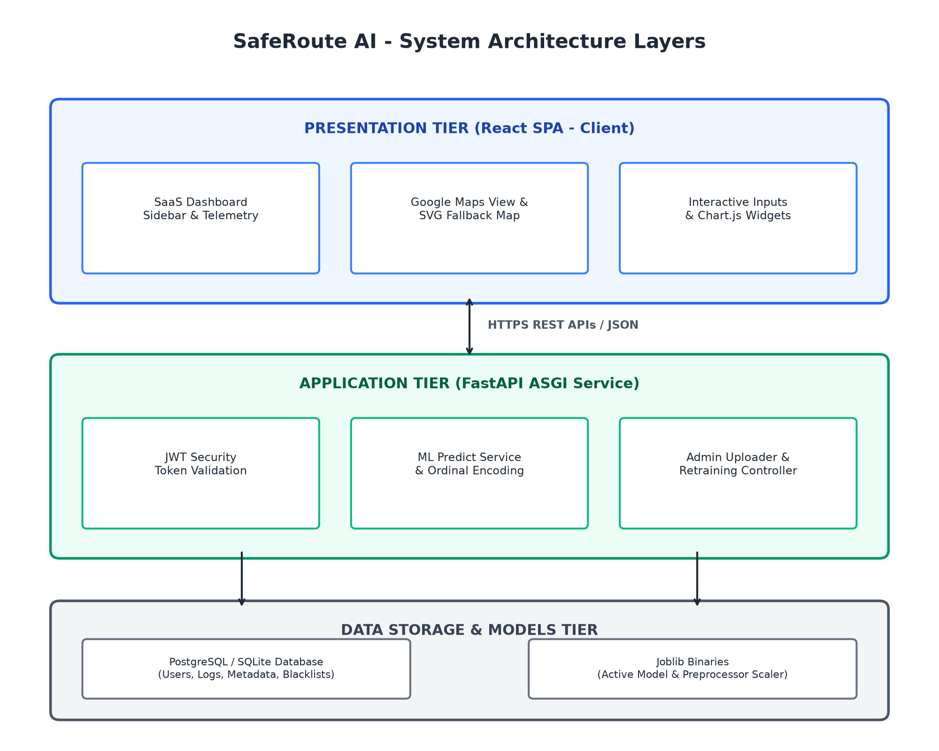
Figure 3.1 - SafeRoute AI System Architecture Context Diagram
System Workflow (Flowchart)
The user registers and logs in via `/login`. After authentication, they access `/dashboard` where Google Maps loads in dark mode. The user inputs travel parameters, and the backend returns a prediction payload with the risk score, category, and confidence rating. The client visualizes the risk using map overlays and stores the prediction in the history database. Administrators can access the admin panel to upload datasets and trigger retraining, logging all activities to the database.
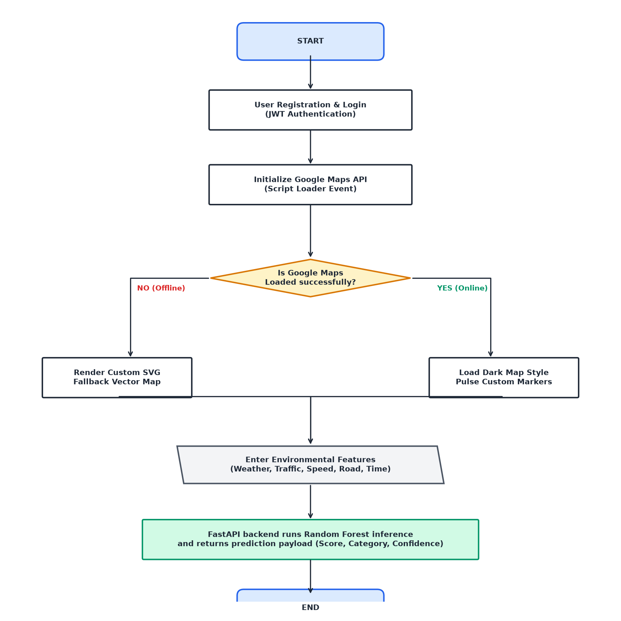
Figure 3.2 - SafeRoute AI Process Workflow Flowchart
Module Design
- User Authentication: Manages registration and login, generating JWT tokens and storing JTIs to prevent replay attacks.
- Map Integration: Loads Google Maps JS with custom markers, and renders the SVG fallback map if the API is offline.
- AI Risk Prediction: Takes travel inputs and queries the Random Forest model, returning risk categories and confidence metrics.
- Dataset Upload: Enables administrators to upload training datasets, validating schemas and calculating SHA-256 hashes.
- Model Retraining: Compares candidate and active models, promoting the candidate if F1 scores improve and latency matches SLA.
- Dashboard Analytics: Displays CPU usage, memory allocations, API request counters, and retraining history.
- System Audit Logs: Logs administrative actions to prevent privilege escalation.
Database Design
SafeRoute AI uses a relational database schema designed to support user authentication, risk auditing, and dataset cataloging. The Users table is linked to the prediction logs, dataset uploads, and audit records, ensuring data integrity.
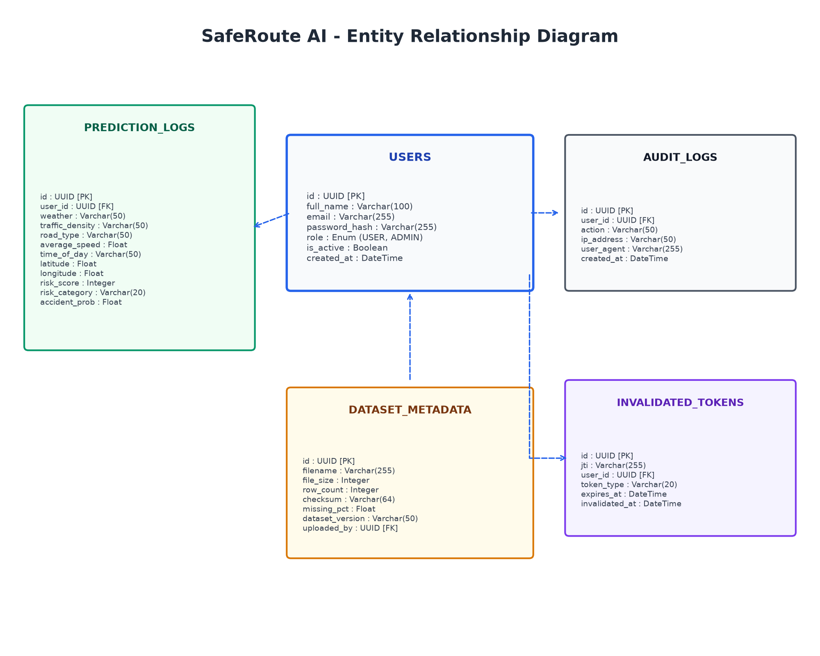

Figure 3.3 - Entity Relationship Diagram
Table 3.1 Users
Field Name | Data Type | Description
id | UUID (PK) | Unique user identifier
full_name | Varchar(100) | Full name of the user
email | Varchar(255) | Unique login email address
password_hash | Varchar(255) | Bcrypt hashed password
role | Enum (USER, ADMIN) | User authorization level
is_active | Boolean | User status indicator
created_at | DateTime | Timestamp of account registration
Table 3.2 PredictionLogs
Field Name | Data Type | Description
id | UUID (PK) | Unique prediction log identifier
user_id | UUID (FK) | References Users table
weather | Varchar(50) | Weather inputs (Rainy, Clear, etc.)
traffic_density | Varchar(50) | Traffic inputs (High, Jammed, etc.)
road_type | Varchar(50) | Road type inputs (Highway, etc.)
average_speed | Float | Average speed parameter
time_of_day | Varchar(50) | Time inputs (Night, Morning, etc.)
latitude | Float | Latitude coordinates of hotspot
longitude | Float | Longitude coordinates of hotspot
risk_score | Integer | Risk score result (0-100)
risk_category | Varchar(20) | Low, Medium, High, Critical
accident_probability | Float | Confidence score percentage
Table 3.3 DatasetMetadata
Field Name | Data Type | Description
id | UUID (PK) | Unique dataset upload identifier
filename | Varchar(255) | Name of the uploaded CSV file
file_size | Integer | Size of file in bytes
row_count | Integer | Number of training sample rows
checksum | Varchar(64) | SHA-256 integrity hash
missing_percentage | Float | Percentage of null elements in file
dataset_version | Varchar(50) | Semantic version number
uploaded_by | UUID (FK) | References Users table
Table 3.4 AuditLogs
Field Name | Data Type | Description
id | UUID (PK) | Unique audit log identifier
user_id | UUID (FK) | References Users table
action | Varchar(50) | Performed administrative action
ip_address | Varchar(50) | IP of client requester
user_agent | Varchar(255) | User Agent of requester
created_at | DateTime | Action execution timestamp
Table 3.5 InvalidatedTokens
Field Name | Data Type | Description
id | UUID (PK) | Unique token log identifier
jti | Varchar(255) | Unique token identifier stored in db
user_id | UUID (FK) | References Users table
token_type | Varchar(20) | Access or Refresh token description
expires_at | DateTime | Expiration timestamp of token
invalidated_at | DateTime | Blacklisting timestamp of token
CONCLUSION
SafeRoute AI is a proactive road safety platform that integrates machine learning risk prediction with dark-themed GIS visualizations. By utilizing a Random Forest Classifier and dynamic maps, the system provides commuters and municipal operators with real-time hazard analytics.
The project aligns with SDG 3 (Good Health and Well-being) by helping reduce traffic accidents, and SDG 11 (Sustainable Cities) by supporting urban safety. With secure session blacklisting, rate-limiting, and an SVG fallback map, SafeRoute AI provides a resilient, production-ready solution for proactive accident prevention.

